Міністерство освіти і науки України
Національний університет «Запорізька Політехніка»
Кафедра програмних засобів

ЗВІТ
з лабораторної роботи №5
з дисципліни «Веб технології та Веб дизайн» на тему:
«Відображення документа на багатьох пристроях»

Виконав:
Студент групи КНТ-122 О. А. Онищенко

Прийняли:
Старший викладач: С. Д. Леощенко

2023

5 ВІДОБРАЖЕННЯ ДОКУМЕНТА НА БАГАТЬОХ ПРИСТРОЯХ

Мета роботи

Дослідити проблеми відображення web-сторінок на різних пристроях та вивчити способи їх усунення.

Завдання до роботи

1. Ознайомитися з теоретичними відомостями, необхідними для виконання роботи.
2. Змінити стилі сторінок, розроблених в лабораторній роботі No4 таким чином, щоб вони стали зручними для викорис-тання на пристроях з розмірами екрану від 320px до 1920px. Для перевірки відображення можна використовувати вбудований ему-лятор інспектора коду Google Chrome.
3. Оформити звіт з роботи.
4. Відповісти на контрольні питання.

Результати виконання роботи

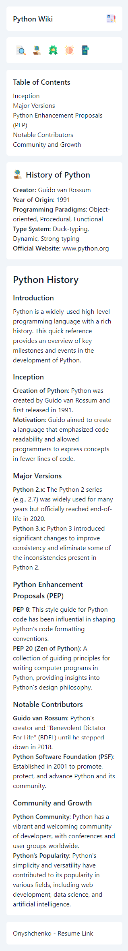
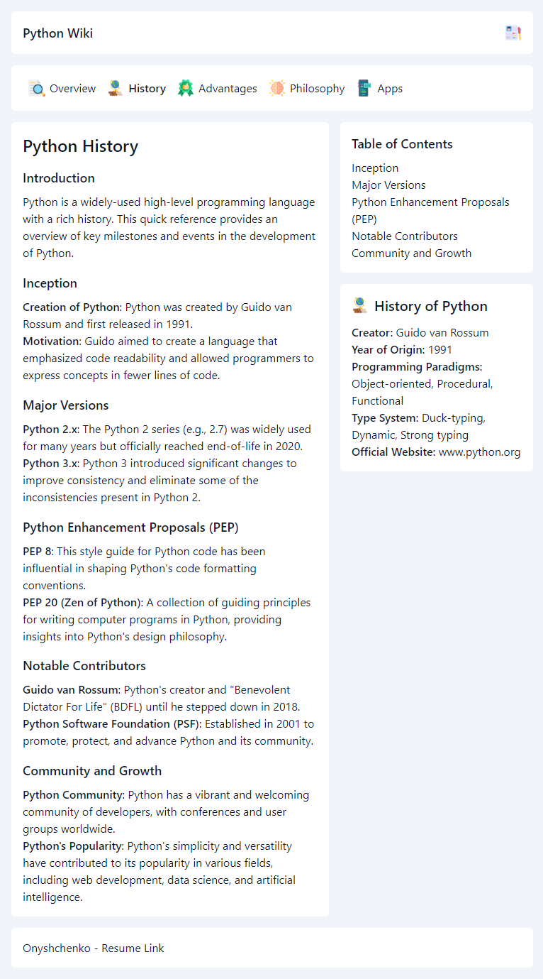
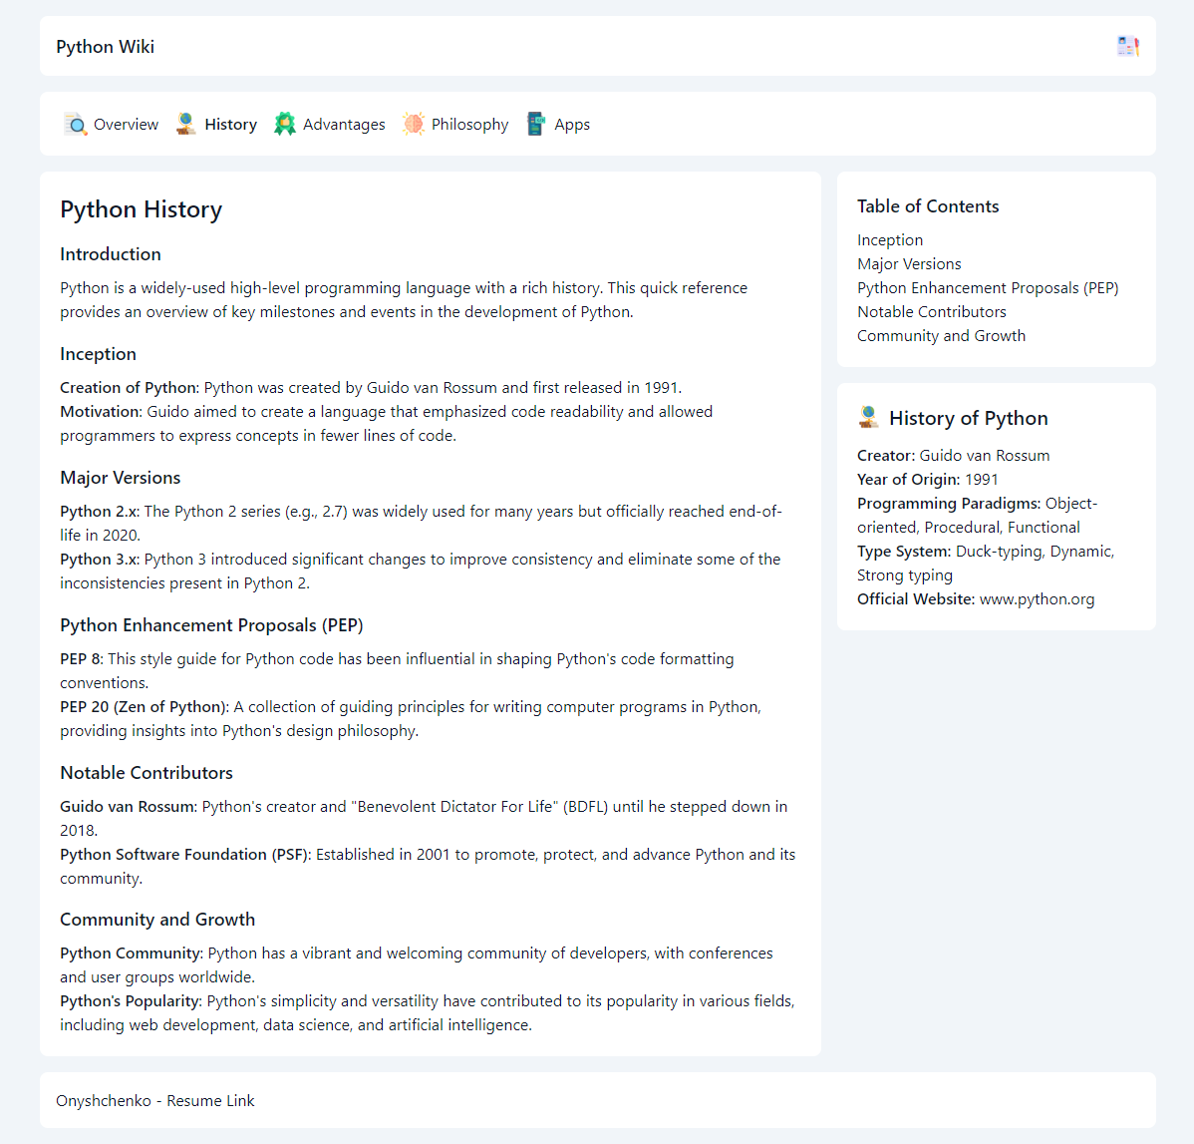
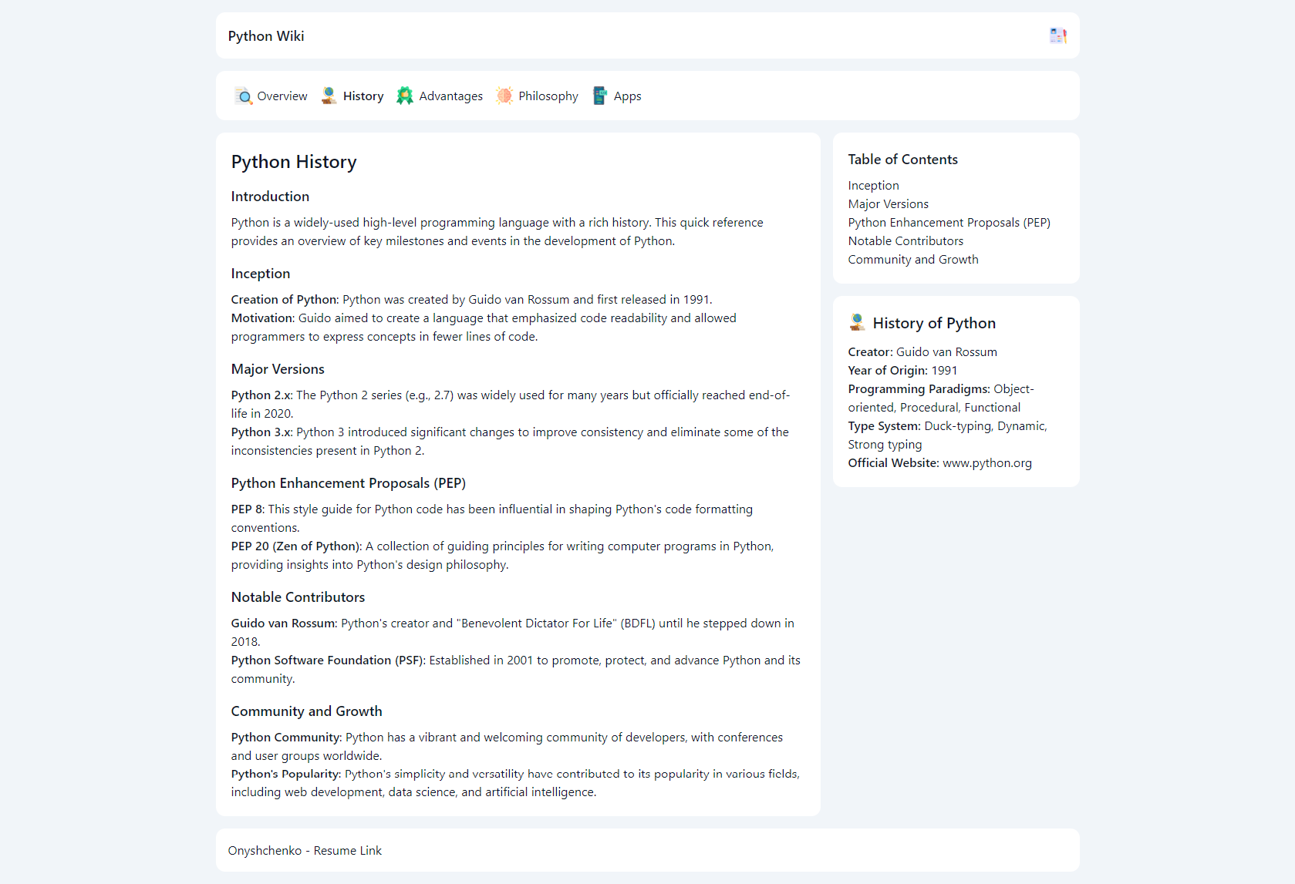

Код

<!-- examples.html -->

<!DOCTYPE html>
<html lang="en" class="scroll-smooth">
<head>
<meta charset="UTF-8" />
<meta name="viewport" content="width=device-width, initial-scale=1.0" />
<title>App Examples - Python Wiki</title>
<link rel="stylesheet" href="./css/base.css" />
<link rel="stylesheet" href="./css/classes.css" />
<link rel="stylesheet" href="./css/custom.css" />
<link rel="shortcut icon" href="./img/snake.png" type="image/x-icon" />
</head>
<body>
<div class="min-h-screen w-full bg-slate-100 text-slate-900">
<div class="mx-auto grid max-w-6xl gap-4 p-4">
<header
class="flex items-center justify-between rounded-md lg:rounded-lg xl:rounded-xl bg-white p-4"
>
<a href="./index.html" class="text-lg font-medium">Python Wiki</a>
<a href="./lab3/index.html" title="View resume">
<img
src="./img/cv.png"
alt="resume logo image link"
class="h-6 w-6"
/>
</a>
</header>

<nav
class="bg-white rounded-md lg:rounded-lg xl:rounded-xl p-4 flex items-center"
>
<a
href="./index.html"
title="Overview"
class="flex items-start gap-1.5 navbar-link-container rounded-md px-2 py-1 cursor-pointer"
>
<img
src="./img/overview.png"
alt="section icon image"
class="w-6 h-6"
/>
<span class="hidden sm:block">Overview</span>
</a>
<a
href="./history.html"
title="History"
class="flex items-start gap-1.5 navbar-link-container rounded-md px-2 py-1 cursor-pointer"
><img
src="./img/history.png"
alt="section icon image"
class="w-6 h-6"
/>
<span class="hidden sm:block">History</span>
</a>
<a
href="./advantages.html"
title="Advantages"
class="flex items-start gap-1.5 navbar-link-container rounded-md px-2 py-1 cursor-pointer"
>
<img
src="./img/advantages.png"
alt="section icon image"
class="w-6 h-6"
/>
<span class="hidden sm:block">Advantages</span>
</a>
<a
href="./philosophy.html"
title="Philosophy"
class="flex items-start gap-1.5 navbar-link-container rounded-md px-2 py-1 cursor-pointer"
>
<img
src="./img/philosophy.png"
alt="section icon image"
class="w-6 h-6"
/>
<span class="hidden sm:block">Philosophy</span>
</a>
<a
href="./examples.html"
title="Code examples"
class="flex items-start gap-1.5 navbar-link-container rounded-md px-2 py-1 cursor-pointer font-medium"
>
<img
src="./img/apps.png"
alt="section icon image"
class="w-6 h-6"
/>
<span class="hidden sm:block">Apps</span>
</a>
</nav>

<section class="grid gap-4 md:flex md:flex-row-reverse">
<div class="grid gap-4 md:flex md:flex-col md:w-[17rem] lg:w-[20rem]">
<nav
class="grid rounded-md lg:rounded-lg xl:rounded-xl bg-white p-4 lg:p-5"
>
<h2 class="pb-2">Table of Contents</h2>
<ol>
<li><a href="#hello-world">Hello, World!</a></li>
<li><a href="#web-development">Web Development</a></li>
<li><a href="#data-analysis">Data Analysis</a></li>
<li><a href="#machine-learning">Machine Learning</a></li>
<li><a href="#automation">Automation</a></li>
<li><a href="#game-development">Game Development</a></li>
</ol>
</nav>

<aside
class="grid rounded-md lg:rounded-lg xl:rounded-xl bg-white p-4 lg:p-5"
>
<div class="flex items-center gap-2 pb-3">
<img
src="./img/apps.png"
alt="python logo image"
class="h-6 w-6"
/>
<h2 class="text-xl font-medium">Apps with Python</h2>
</div>

<ul>
<li>
<strong>Popular Libraries:</strong> Django, Flask, NumPy,
SciPy, TensorFlow
</li>
<li>
<strong>Common Use Cases:</strong> Web Development, Data
Analysis, Machine Learning, AI
</li>
<li>
<strong>Notable Python Programs:</strong> YouTube, Instagram,
Spotify, Reddit
</li>
<li><strong>Python Version:</strong> Python 3.x</li>
<li>
<strong>Official Python Documentation:</strong>
<a href="https://docs.python.org/3/">docs.python.org/3</a>
</li>
</ul>
</aside>
</div>

<main
class="grid rounded-md lg:rounded-lg xl:rounded-xl bg-white p-4 lg:p-5 flex-1"
>
<h1>Python Examples of Programs</h1>

<h2 class="first-heading">Introduction</h2>
<p>
Python is a versatile programming language that can be used for a
wide range of applications. This quick reference provides examples
of Python programs across various domains to showcase its
practicality and versatility.
</p>

<h2 id="hello-world">Hello, World!</h2>
<p>
<strong>Hello, World!</strong>: The classic introductory program
that displays "Hello, World!" on the screen.
</p>
<code>
<pre>
print("Hello, World!")
</pre
>
</code>

<h2 id="web-development">Web Development</h2>
<p>
<strong>Simple Web Server</strong>: Create a basic web server
using Python's built-in <code>http.server</code> module.
</p>
<code>
<pre>
import http.server
import socketserver

PORT = 8000

with socketserver.TCPServer(
("", PORT),
http.server.SimpleHTTPRequestHandler
) as httpd:
print("Serving at port", PORT)
httpd.serve_forever()
</pre
>
</code>

<h2 id="data-analysis">Data Analysis</h2>
<p>
<strong>Data Visualization</strong>: Use libraries like Matplotlib
and Pandas to create interactive data visualizations.
</p>
<code>
<pre>
import matplotlib.pyplot as plt
import pandas as pd

# Create a simple plot
data = {'x': [1, 2, 3, 4, 5],
'y': [10, 12, 5, 8, 7]}
df = pd.DataFrame(data)
plt.plot(df['x'], df['y'])
plt.xlabel('X-axis')
plt.ylabel('Y-axis')
plt.title('Simple Data Plot')
plt.show()
</pre
>
</code>

<h2 id="machine-learning">Machine Learning</h2>
<p>
<strong>Linear Regression</strong>: Implement a simple linear
regression model using Scikit-Learn.
</p>
<code>
<pre>
from sklearn import linear_model

# Sample data
X = [[1], [2], [3], [4], [5]]
y = [10, 12, 5, 8, 7]

# Create a linear regression model
model = linear_model.LinearRegression()
model.fit(X, y)

# Predict values
predicted = model.predict([[6]])
print("Predicted:", predicted[0])
</pre
>
</code>

<h2 id="automation">Automation</h2>
<p>
<strong>File Backup Script</strong>: Create a Python script to
automate file backups to a specified location.
</p>
<code>
<pre>
import shutil

source_dir = '/path/to/source'
backup_dir = '/path/to/backup'

shutil.copytree(source_dir, backup_dir)
</pre
>
</code>

<h2 id="game-development">Game Development</h2>
<p>
<strong>Simple Game Using Pygame</strong>: Develop a basic game
using the Pygame library.
</p>
<code>
<pre>
import pygame
import sys

# Initialize Pygame
pygame.init()

# Create a game window
screen = pygame.display.set_mode(
(800, 600)
)
pygame.display.set_caption(
"Simple Game"
)

# Main game loop
while True:
for event in pygame.event.get():
if event.type == pygame.QUIT:
pygame.quit()
sys.exit()

pygame.display.update()
</pre
>
</code>
</main>
</section>

<footer
class="grid rounded-md lg:rounded-lg xl:rounded-xl bg-white p-4"
>
<a href="./lab3/index.html">Onyshchenko - Resume Link</a>
</footer>
</div>
</div>
</body>
</html>

<!-- advantages.html -->

<!DOCTYPE html>
<html lang="en" class="scroll-smooth">
<head>
<meta charset="UTF-8" />
<meta name="viewport" content="width=device-width, initial-scale=1.0" />
<title>Advantages - Python Wiki</title>
<link rel="stylesheet" href="./css/base.css" />
<link rel="stylesheet" href="./css/classes.css" />
<link rel="stylesheet" href="./css/custom.css" />
<link rel="shortcut icon" href="./img/snake.png" type="image/x-icon" />
</head>
<body>
<div class="min-h-screen w-full bg-slate-100 text-slate-900">
<div class="mx-auto grid max-w-6xl gap-4 p-4">
<header
class="flex items-center justify-between rounded-md lg:rounded-lg xl:rounded-xl bg-white p-4"
>
<a href="./index.html" class="text-lg font-medium">Python Wiki</a>
<a href="./lab3/index.html" title="View resume">
<img
src="./img/cv.png"
alt="resume logo image link"
class="h-6 w-6"
/>
</a>
</header>

<nav
class="bg-white rounded-md lg:rounded-lg xl:rounded-xl p-4 flex items-center"
>
<a
href="./index.html"
title="Overview"
class="flex items-start gap-1.5 navbar-link-container rounded-md px-2 py-1 cursor-pointer"
>
<img
src="./img/overview.png"
alt="section icon image"
class="w-6 h-6"
/>
<span class="hidden sm:block">Overview</span>
</a>
<a
href="./history.html"
title="History"
class="flex items-start gap-1.5 navbar-link-container rounded-md px-2 py-1 cursor-pointer"
><img
src="./img/history.png"
alt="section icon image"
class="w-6 h-6"
/>
<span class="hidden sm:block">History</span>
</a>
<a
href="./advantages.html"
title="Advantages"
class="flex items-start gap-1.5 navbar-link-container rounded-md px-2 py-1 cursor-pointer font-medium"
>
<img
src="./img/advantages.png"
alt="section icon image"
class="w-6 h-6"
/>
<span class="hidden sm:block">Advantages</span>
</a>
<a
href="./philosophy.html"
title="Philosophy"
class="flex items-start gap-1.5 navbar-link-container rounded-md px-2 py-1 cursor-pointer"
>
<img
src="./img/philosophy.png"
alt="section icon image"
class="w-6 h-6"
/>
<span class="hidden sm:block">Philosophy</span>
</a>
<a
href="./examples.html"
title="Code examples"
class="flex items-start gap-1.5 navbar-link-container rounded-md px-2 py-1 cursor-pointer"
>
<img
src="./img/apps.png"
alt="section icon image"
class="w-6 h-6"
/>
<span class="hidden sm:block">Apps</span>
</a>
</nav>

<section class="grid gap-4 md:flex md:flex-row-reverse">
<div class="grid gap-4 md:flex md:flex-col md:w-[17rem] lg:w-[20rem]">
<nav
class="grid rounded-md lg:rounded-lg xl:rounded-xl bg-white p-4 lg:p-5"
>
<h2 class="pb-2">Table of Contents</h2>
<ol>
<li><a href="#readability">Readability</a></li>
<li><a href="#versatility">Versatility</a></li>
<li><a href="#community-support">Community Support</a></li>
<li>
<a href="#vast-library-ecosystem">Vast Library Ecosystem</a>
</li>
<li><a href="#cross-platform">Cross-Platform</a></li>
<li><a href="#simplicity">Simplicity</a></li>
</ol>
</nav>
<aside
class="grid rounded-md lg:rounded-lg xl:rounded-xl bg-white p-4 lg:p-5"
>
<div class="flex items-center gap-2 pb-3">
<img
src="./img/advantages.png"
alt="python logo image"
class="h-6 w-6"
/>
<h2 class="text-xl font-medium">Advantages of Python</h2>
</div>

<ul>
<li><strong>Creator:</strong> Guido van Rossum</li>
<li><strong>Year of Origin:</strong> 1991</li>
<li>
<strong>Readability:</strong> Python's syntax promotes code
readability.
</li>
<li>
<strong>Large Standard Library:</strong> Python has a
comprehensive standard library.
</li>
<li>
<strong>Versatility:</strong> Python can be used for web
development, data analysis, and more.
</li>
<li>
<strong>Official Documentation:</strong>
<a href="https://docs.python.org/3/">docs.python.org/3</a>
</li>
</ul>
</aside>
</div>

<main
class="grid rounded-md lg:rounded-lg xl:rounded-xl bg-white p-4 lg:p-5 flex-1"
>
<h1>Python Advantages</h1>

<h2 class="first-heading">Introduction</h2>
<p>
Python is a versatile programming language known for its numerous
advantages in various domains. This quick reference provides an
overview of the key benefits of using Python.
</p>

<h2 id="readability">Readability</h2>
<p>
<strong>Clear and Readable Syntax</strong>: Python's syntax
emphasizes readability and reduces the cost of program
maintenance.
</p>
<p>
<strong>Indentation-based Structure</strong>: Python enforces code
indentation, making the code structure visually clear and
consistent.
</p>

<h2 id="versatility">Versatility</h2>
<p>
<strong>General-Purpose Language</strong>: Python can be used for
a wide range of applications, including web development, data
analysis, machine learning, and more.
</p>
<p>
<strong>Integration Capabilities</strong>: Python easily
integrates with other languages and tools, facilitating complex
projects.
</p>

<h2 id="community-support">Community Support</h2>
<p>
<strong>Active Community</strong>: Python has a large and active
community of developers who provide support, share knowledge, and
create open-source libraries.
</p>
<p>
<strong>Documentation and Resources</strong>: Abundant
documentation and online resources are available for Python users,
making it easy to learn and troubleshoot.
</p>

<h2 id="vast-library-ecosystem">Vast Library Ecosystem</h2>
<p>
<strong>Rich Standard Library</strong>: Python's standard library
includes modules for various tasks, reducing the need for external
dependencies.
</p>
<p>
<strong>Third-Party Libraries</strong>: Python boasts a vast
ecosystem of third-party libraries and frameworks for specific
domains, enhancing productivity.
</p>

<h2 id="cross-platform">Cross-Platform</h2>
<p>
<strong>Platform Independence</strong>: Python code can run on
multiple platforms without modification, increasing portability.
</p>
<p>
<strong>Support for Major Operating Systems</strong>: Python
supports Windows, macOS, Linux, and more.
</p>

<h2 id="simplicity">Simplicity</h2>
<p>
<strong>Minimalistic Syntax</strong>: Python's clean and
minimalistic syntax reduces the learning curve for beginners.
</p>
<p>
<strong>Expressive and Concise Code</strong>: Python allows
developers to express complex ideas in fewer lines of code.
</p>
</main>
</section>

<footer
class="grid rounded-md lg:rounded-lg xl:rounded-xl bg-white p-4"
>
<a href="./lab3/index.html">Onyshchenko - Resume Link</a>
</footer>
</div>
</div>
</body>
</html>

<!-- history.html -->

<!DOCTYPE html>
<html lang="en" class="scroll-smooth">
<head>
<meta charset="UTF-8" />
<meta name="viewport" content="width=device-width, initial-scale=1.0" />
<title>History - Python Wiki</title>
<link rel="stylesheet" href="./css/base.css" />
<link rel="stylesheet" href="./css/classes.css" />
<link rel="stylesheet" href="./css/custom.css" />
<link rel="shortcut icon" href="./img/snake.png" type="image/x-icon" />
</head>
<body>
<div class="min-h-screen w-full bg-slate-100 text-slate-900">
<div class="mx-auto grid max-w-6xl gap-4 p-4">
<header
class="flex items-center justify-between rounded-md lg:rounded-lg xl:rounded-xl bg-white p-4"
>
<a href="./index.html" class="text-lg font-medium">Python Wiki</a>
<a href="./lab3/index.html" title="View resume">
<img
src="./img/cv.png"
alt="resume logo image link"
class="h-6 w-6"
/>
</a>
</header>

<nav
class="bg-white rounded-md lg:rounded-lg xl:rounded-xl p-4 flex items-center"
>
<a
href="./index.html"
title="Overview"
class="flex items-start gap-1.5 navbar-link-container rounded-md px-2 py-1 cursor-pointer"
>
<img
src="./img/overview.png"
alt="section icon image"
class="w-6 h-6"
/>
<span class="hidden sm:block">Overview</span>
</a>
<a
href="./history.html"
title="History"
class="flex items-start gap-1.5 navbar-link-container rounded-md px-2 py-1 cursor-pointer font-medium"
><img
src="./img/history.png"
alt="section icon image"
class="w-6 h-6"
/>
<span class="hidden sm:block">History</span>
</a>
<a
href="./advantages.html"
title="Advantages"
class="flex items-start gap-1.5 navbar-link-container rounded-md px-2 py-1 cursor-pointer"
>
<img
src="./img/advantages.png"
alt="section icon image"
class="w-6 h-6"
/>
<span class="hidden sm:block">Advantages</span>
</a>
<a
href="./philosophy.html"
title="Philosophy"
class="flex items-start gap-1.5 navbar-link-container rounded-md px-2 py-1 cursor-pointer"
>
<img
src="./img/philosophy.png"
alt="section icon image"
class="w-6 h-6"
/>
<span class="hidden sm:block">Philosophy</span>
</a>
<a
href="./examples.html"
title="Code examples"
class="flex items-start gap-1.5 navbar-link-container rounded-md px-2 py-1 cursor-pointer"
>
<img
src="./img/apps.png"
alt="section icon image"
class="w-6 h-6"
/>
<span class="hidden sm:block">Apps</span>
</a>
</nav>

<section
class="grid gap-4 md:flex md:flex-row-reverse flex-row-reverse"
>
<div class="grid gap-4 md:flex md:flex-col md:w-[17rem] lg:w-[20rem]">
<nav
class="grid rounded-md lg:rounded-lg xl:rounded-xl bg-white p-4 lg:p-5"
>
<h2 class="pb-2">Table of Contents</h2>
<ol>
<li><a href="#inception">Inception</a></li>
<li><a href="#major-versions">Major Versions</a></li>
<li>
<a href="#python-enhancement-proposals-pep"
>Python Enhancement Proposals (PEP)</a
>
</li>
<li>
<a href="#notable-contributors">Notable Contributors</a>
</li>
<li>
<a href="#community-and-growth">Community and Growth</a>
</li>
</ol>
</nav>

<aside
class="grid rounded-md lg:rounded-lg xl:rounded-xl bg-white p-4 lg:p-5"
>
<div class="flex items-center gap-2 pb-3">
<img
src="./img/history.png"
alt="python logo image"
class="h-6 w-6"
/>
<h2 class="text-xl font-medium">History of Python</h2>
</div>

<ul>
<li><strong>Creator:</strong> Guido van Rossum</li>
<li><strong>Year of Origin:</strong> 1991</li>
<li>
<strong>Programming Paradigms:</strong> Object-oriented,
Procedural, Functional
</li>
<li>
<strong>Type System:</strong> Duck-typing, Dynamic, Strong
typing
</li>
<li>
<strong>Official Website:</strong>
<a href="https://www.python.org/">www.python.org</a>
</li>
</ul>
</aside>
</div>

<main
class="grid rounded-md lg:rounded-lg xl:rounded-xl bg-white p-4 lg:p-5 flex-1"
>
<h1 class="text-2xl font-semibold pb-4">Python History</h1>

<h2 class="first-heading">Introduction</h2>
<p>
Python is a widely-used high-level programming language with a
rich history. This quick reference provides an overview of key
milestones and events in the development of Python.
</p>

<h2 id="inception">Inception</h2>
<p>
<strong>Creation of Python</strong>: Python was created by Guido
van Rossum and first released in 1991.
</p>
<p>
<strong>Motivation</strong>: Guido aimed to create a language that
emphasized code readability and allowed programmers to express
concepts in fewer lines of code.
</p>

<h2 id="major-versions">Major Versions</h2>
<p>
<strong>Python 2.x</strong>: The Python 2 series (e.g., 2.7) was
widely used for many years but officially reached end-of-life in
2020.
</p>
<p>
<strong>Python 3.x</strong>: Python 3 introduced significant
changes to improve consistency and eliminate some of the
inconsistencies present in Python 2.
</p>

<h2 id="python-enhancement-proposals-pep">
Python Enhancement Proposals (PEP)
</h2>
<p>
<strong>PEP 8</strong>: This style guide for Python code has been
influential in shaping Python's code formatting conventions.
</p>
<p>
<strong>PEP 20 (Zen of Python)</strong>: A collection of guiding
principles for writing computer programs in Python, providing
insights into Python's design philosophy.
</p>

<h2 id="notable-contributors">Notable Contributors</h2>
<p>
<strong>Guido van Rossum</strong>: Python's creator and
"Benevolent Dictator For Life" (BDFL) until he stepped down in
2018.
</p>
<p>
<strong>Python Software Foundation (PSF)</strong>: Established in
2001 to promote, protect, and advance Python and its community.
</p>

<h2 id="community-and-growth">Community and Growth</h2>
<p>
<strong>Python Community</strong>: Python has a vibrant and
welcoming community of developers, with conferences and user
groups worldwide.
</p>
<p>
<strong>Python's Popularity</strong>: Python's simplicity and
versatility have contributed to its popularity in various fields,
including web development, data science, and artificial
intelligence.
</p>
</main>
</section>

<footer
class="grid rounded-md lg:rounded-lg xl:rounded-xl bg-white p-4"
>
<a href="./lab3/index.html">Onyshchenko - Resume Link</a>
</footer>
</div>
</div>
</body>
</html>

<!-- index.html -->

<!DOCTYPE html>
<html lang="en" class="scroll-smooth">
<head>
<meta charset="UTF-8" />
<meta name="viewport" content="width=device-width, initial-scale=1.0" />
<title>Overview - Python Wiki</title>
<link rel="stylesheet" href="./css/base.css" />
<link rel="stylesheet" href="./css/classes.css" />
<link rel="stylesheet" href="./css/custom.css" />
<link rel="shortcut icon" href="./img/snake.png" type="image/x-icon" />
</head>
<body>
<div class="min-h-screen w-full bg-slate-100 text-slate-900">
<div class="mx-auto grid max-w-6xl gap-4 p-4">
<header
class="flex items-center justify-between rounded-md lg:rounded-lg xl:rounded-xl bg-white p-4"
>
<a href="./index.html" class="text-lg font-medium">Python Wiki</a>
<a href="./lab3/index.html" title="View resume">
<img
src="./img/cv.png"
alt="resume logo image link"
class="h-6 w-6"
/>
</a>
</header>

<nav
class="bg-white rounded-md lg:rounded-lg xl:rounded-xl p-4 flex items-center"
>
<a
href="./index.html"
title="Overview"
class="flex items-start gap-1.5 navbar-link-container rounded-md px-2 py-1 cursor-pointer font-medium"
>
<img
src="./img/overview.png"
alt="section icon image"
class="w-6 h-6"
/>
<span class="hidden sm:block">Overview</span>
</a>
<a
href="./history.html"
title="History"
class="flex items-start gap-1.5 navbar-link-container rounded-md px-2 py-1 cursor-pointer"
><img
src="./img/history.png"
alt="section icon image"
class="w-6 h-6"
/>
<span class="hidden sm:block">History</span>
</a>
<a
href="./advantages.html"
title="Advantages"
class="flex items-start gap-1.5 navbar-link-container rounded-md px-2 py-1 cursor-pointer"
>
<img
src="./img/advantages.png"
alt="section icon image"
class="w-6 h-6"
/>
<span class="hidden sm:block">Advantages</span>
</a>
<a
href="./philosophy.html"
title="Philosophy"
class="flex items-start gap-1.5 navbar-link-container rounded-md px-2 py-1 cursor-pointer"
>
<img
src="./img/philosophy.png"
alt="section icon image"
class="w-6 h-6"
/>
<span class="hidden sm:block">Philosophy</span>
</a>
<a
href="./examples.html"
title="Code examples"
class="flex items-start gap-1.5 navbar-link-container rounded-md px-2 py-1 cursor-pointer"
>
<img
src="./img/apps.png"
alt="section icon image"
class="w-6 h-6"
/>
<span class="hidden sm:block">Apps</span>
</a>
</nav>

<section class="grid gap-4 md:flex md:flex-row-reverse">
<div class="grid gap-4 md:flex md:flex-col md:w-[17rem] lg:w-[20rem]">
<nav
class="grid rounded-md lg:rounded-lg xl:rounded-xl bg-white p-4 lg:p-5"
>
<h2 class="pb-2">Table of Contents</h2>

<ol>
<li>
<a href="#variables-and-data-types"
>Variables and Data Types</a
>
</li>
<li>
<a href="#conditional-statements">Conditional Statements</a>
</li>
<li><a href="#loops">Loops</a></li>
<li><a href="#functions">Functions</a></li>
<li><a href="#lists">Lists</a></li>
<li><a href="#dictionaries">Dictionaries</a></li>
<li><a href="#strings">Strings</a></li>
<li><a href="#file-handling">File Handling</a></li>
</ol>
</nav>

<aside
class="grid rounded-md lg:rounded-lg xl:rounded-xl bg-white p-4 lg:p-5"
>
<div class="flex items-center gap-2 pb-3">
<img
src="./img/overview.png"
alt="python logo image"
class="h-6 w-6"
/>
<h2 class="text-xl font-medium">Python Lanugage</h2>
</div>

<ul>
<li><strong>Designed by:</strong> Guido van Rossum</li>
<li><strong>First appeared:</strong> 1991</li>
<li>
<strong>Paradigms:</strong> Object-oriented, procedural,
functional
</li>
<li>
<strong>Typing discipline:</strong> Duck, dynamic, strong
typing
</li>
<li>
<strong>Website:</strong>
<a href="https://www.python.org/">www.python.org</a>
</li>
</ul>
</aside>
</div>

<main
class="grid rounded-md lg:rounded-lg xl:rounded-xl bg-white p-4 lg:p-5 flex-1"
>
<h1 class="pb-4 text-2xl font-semibold">Python Overview</h1>

<h2 class="first-heading">Introduction</h2>

<p>
Python is a high-level, versatile programming language known for
its simplicity and readability. This quick reference provides an
overview of essential Python concepts and syntax.
</p>

<h2 id="variables-and-data-types">Variables and Data Types</h2>

<ul>
<li>
<strong>Variables:</strong> In Python, you can assign values to
variables using the <code>=</code> operator. Example:
<code>x = 10</code>.
</li>
<li>
<strong>Data Types:</strong> Python supports various data types,
including integers, floats, strings, booleans, and more.
</li>
<li>
<strong>Type Conversion:</strong> You can convert between data
types using functions like <code>int()</code>,
<code>float()</code>, and <code>str()</code>.
</li>
</ul>

<h2 id="conditional-statements">Conditional Statements</h2>

<ul>
<li>
<strong>if Statement:</strong> Use <code>if</code> to execute
code conditionally based on a Boolean expression.
</li>
<li>
<strong>elif and else:</strong> Extend
<code>if</code> statements with <code>elif</code> (else if) and
<code>else</code> for multiple branching.
</li>
</ul>

<h2 id="loops">Loops</h2>

<ul>
<li>
<strong>for Loop:</strong> Iterate over a sequence (e.g., list,
string) using a <code>for</code> loop.
</li>
<li>
<strong>while Loop:</strong> Execute code repeatedly as long as
a condition is true with a <code>while</code> loop.
</li>
</ul>

<h2 id="functions">Functions</h2>

<ul>
<li>
<strong>Defining Functions:</strong> Create reusable code blocks
using the <code>def</code> keyword.
</li>
<li>
<strong>Parameters:</strong> Pass arguments to functions, which
can be optional or required.
</li>
<li>
<strong>Return Values:</strong> Functions can return values
using the <code>return</code> statement.
</li>
</ul>

<h2 id="lists">Lists</h2>

<ul>
<li>
<strong>Creating Lists:</strong> Define lists using square
brackets, e.g., <code>my_list = [1, 2, 3]</code>.
</li>
<li>
<strong>Indexing:</strong> Access list elements using their
index (zero-based).
</li>
<li>
<strong>Slicing:</strong> Extract portions of a list using
slicing, e.g., <code>my_list[1:3]</code>.
</li>
</ul>

<h2 id="dictionaries">Dictionaries</h2>

<ul>
<li>
<strong>Creating Dictionaries:</strong> Define key-value pairs
using curly braces, e.g.,
<code>my_dict = {'name': 'John', 'age': 30}</code>.
</li>
<li>
<strong>Accessing Values:</strong> Retrieve values by specifying
the key.
</li>
</ul>

<h2 id="strings">Strings</h2>

<ul>
<li>
<strong>Creating Strings:</strong> Define strings with single or
double quotes, e.g., <code>"Hello, World!"</code>.
</li>
<li>
<strong>String Methods:</strong> Use built-in string methods for
operations like concatenation and splitting.
</li>
</ul>

<h2 id="file-handling">File Handling</h2>

<ul>
<li>
<strong>Opening Files:</strong> Use <code>open()</code> to open
files for reading or writing.
</li>
<li>
<strong>Reading and Writing:</strong> Read file contents with
<code>read()</code>, write data with <code>write()</code>.
</li>
</ul>

<h3 id="read-more" class="pb-2 font-medium border-t-2 pt-2 mt-6">
Read more
</h3>

<ul>
<li><a href="./history.html">History</a></li>
<li><a href="./advantages.html">Advantages</a></li>
<li><a href="./philosophy.html">Philosophy</a></li>
<li><a href="./examples.html">Examples of programs</a></li>
</ul>
</main>
</section>

<footer
class="grid rounded-md lg:rounded-lg xl:rounded-xl bg-white p-4"
>
<a href="./lab3/index.html">Onyshchenko - Resume Link</a>
</footer>
</div>
</div>
</body>
</html>

<!-- philosophy.html -->

<!DOCTYPE html>
<html lang="en" class="scroll-smooth">
<head>
<meta charset="UTF-8" />
<meta name="viewport" content="width=device-width, initial-scale=1.0" />
<title>Philosophy - Python Wiki</title>
<link rel="stylesheet" href="./css/base.css" />
<link rel="stylesheet" href="./css/classes.css" />
<link rel="stylesheet" href="./css/custom.css" />
<link rel="shortcut icon" href="./img/snake.png" type="image/x-icon" />
</head>
<body>
<div class="min-h-screen w-full bg-slate-100 text-slate-900">
<div class="mx-auto grid max-w-6xl gap-4 p-4">
<header
class="flex items-center justify-between rounded-md lg:rounded-lg xl:rounded-xl bg-white p-4"
>
<a href="./index.html" class="text-lg font-medium">Python Wiki</a>
<a href="./lab3/index.html" title="View resume">
<img
src="./img/cv.png"
alt="resume logo image link"
class="h-6 w-6"
/>
</a>
</header>

<nav
class="bg-white rounded-md lg:rounded-lg xl:rounded-xl p-4 flex items-center"
>
<a
href="./index.html"
title="Overview"
class="flex items-start gap-1.5 navbar-link-container rounded-md px-2 py-1 cursor-pointer"
>
<img
src="./img/overview.png"
alt="section icon image"
class="w-6 h-6"
/>
<span class="hidden sm:block">Overview</span>
</a>
<a
href="./history.html"
title="History"
class="flex items-start gap-1.5 navbar-link-container rounded-md px-2 py-1 cursor-pointer"
><img
src="./img/history.png"
alt="section icon image"
class="w-6 h-6"
/>
<span class="hidden sm:block">History</span>
</a>
<a
href="./advantages.html"
title="Advantages"
class="flex items-start gap-1.5 navbar-link-container rounded-md px-2 py-1 cursor-pointer"
>
<img
src="./img/advantages.png"
alt="section icon image"
class="w-6 h-6"
/>
<span class="hidden sm:block">Advantages</span>
</a>
<a
href="./philosophy.html"
title="Philosophy"
class="flex items-start gap-1.5 navbar-link-container rounded-md px-2 py-1 cursor-pointer font-medium"
>
<img
src="./img/philosophy.png"
alt="section icon image"
class="w-6 h-6"
/>
<span class="hidden sm:block">Philosophy</span>
</a>
<a
href="./examples.html"
title="Code examples"
class="flex items-start gap-1.5 navbar-link-container rounded-md px-2 py-1 cursor-pointer"
>
<img
src="./img/apps.png"
alt="section icon image"
class="w-6 h-6"
/>
<span class="hidden sm:block">Apps</span>
</a>
</nav>

<section class="grid gap-4 md:flex md:flex-row-reverse">
<div class="grid gap-4 md:flex md:flex-col md:w-[17rem] lg:w-[20rem]">
<nav
class="grid rounded-md lg:rounded-lg xl:rounded-xl bg-white p-4 lg:p-5"
>
<h2 class="pb-2">Table of Contents</h2>
<ol>
<li><a href="#zen-of-python">Zen of Python</a></li>
<li><a href="#readability-counts">Readability Counts</a></li>
<li>
<a href="#simple-is-better-than-complex"
>Simple is Better Than Complex</a
>
</li>
<li>
<a href="#explicit-is-better-than-implicit"
>Explicit is Better Than Implicit</a
>
</li>
<li>
<a href="#community-and-collaboration"
>Community and Collaboration</a
>
</li>
<li>
<a href="#practicality-beats-purity"
>Practicality Beats Purity</a
>
</li>
</ol>
</nav>

<aside
class="grid rounded-md lg:rounded-lg xl:rounded-xl bg-white p-4 lg:p-5"
>
<div class="flex items-center gap-2 pb-3">
<img
src="./img/philosophy.png"
alt="python logo image"
class="h-6 w-6"
/>
<h2 class="text-xl font-medium">Philosophy of Python</h2>
</div>

<ul>
<li><strong>Creator:</strong> Guido van Rossum</li>
<li><strong>Year of Origin:</strong> 1991</li>
<li>
<strong>Design Philosophy:</strong> Readability, Simplicity,
Explicit is better than implicit
</li>
<li><strong>Key Principles:</strong> Zen of Python (PEP 20)</li>
<li>
<strong>Notable Quote:</strong> "There should be one-- and
preferably only one --obvious way to do it."
</li>
<li>
<strong>Official Python Documentation:</strong>
<a href="https://docs.python.org/3/">docs.python.org/3</a>
</li>
</ul>
</aside>
</div>

<main
class="grid rounded-md lg:rounded-lg xl:rounded-xl bg-white p-4 lg:p-5 flex-1"
>
<h1>Python Philosophy</h1>

<h2 class="first-heading">Introduction</h2>
<p>
Python is not just a programming language; it also embodies a set
of guiding principles and philosophies that shape its design and
usage. This quick reference provides an overview of the key
philosophies that define Python's ethos.
</p>

<h2 id="zen-of-python">Zen of Python</h2>
<p>
<strong>The Zen of Python</strong>: A collection of guiding
aphorisms that capture Python's design philosophy and principles.
</p>
<p>
<strong>Readability Counts</strong>: Python code should be easy to
read and understand, even by those who didn't write it.
</p>

<h2 id="readability-counts">Readability Counts</h2>
<p>
<strong>Readability</strong>: Python's emphasis on clean and
readable code makes it easier to maintain and collaborate on
projects.
</p>
<p>
<strong>Code as Communication</strong>: Python code should
communicate its purpose clearly, making it accessible to others.
</p>

<h2 id="simple-is-better-than-complex">
Simple is Better Than Complex
</h2>
<p>
<strong>Simplicity</strong>: Python values simplicity in design
and implementation, favoring straightforward solutions over
complex ones.
</p>
<p>
<strong>Minimize Cognitive Load</strong>: Simple code reduces
cognitive load, making it easier for developers to understand and
modify.
</p>

<h2 id="explicit-is-better-than-implicit">
Explicit is Better Than Implicit
</h2>
<p>
<strong>Clarity</strong>: Python encourages explicit code that
leaves no room for ambiguity or hidden behavior.
</p>
<p>
<strong>Obviousness</strong>: Code should be obvious in its intent
and actions, minimizing surprises.
</p>

<h2 id="community-and-collaboration">
Community and Collaboration
</h2>
<p>
<strong>Community</strong>: Python's community-driven development
fosters collaboration, knowledge sharing, and support.
</p>
<p>
<strong>Open Source</strong>: Python's open-source nature promotes
transparency, allowing anyone to contribute and improve the
language.
</p>

<h2 id="practicality-beats-purity">Practicality Beats Purity</h2>
<p>
<strong>Real-World Solutions</strong>: Python prioritizes
practical solutions that address real-world problems over rigid
purity.
</p>
<p>
<strong>Flexibility</strong>: Python's flexibility allows
developers to choose the best tool for the job.
</p>
</main>
</section>

<footer
class="grid rounded-md lg:rounded-lg xl:rounded-xl bg-white p-4"
>
<a href="./lab3/index.html">Onyshchenko - Resume Link</a>
</footer>
</div>
</div>
</body>
</html>

/* base.css */

*,
::before,
::after {
box-sizing: border-box;
border-width: 0;
border-style: solid;
border-color: #e5e7eb;
}

::before,
::after {
--tw-content: "";
}

html {
line-height: 1.5;
-webkit-text-size-adjust: 100%;
-moz-tab-size: 4;
tab-size: 4;
font-family: ui-sans-serif, system-ui, -apple-system, BlinkMacSystemFont,
"Segoe UI", Roboto, "Helvetica Neue", Arial, "Noto Sans", sans-serif,
"Apple Color Emoji", "Segoe UI Emoji", "Segoe UI Symbol", "Noto Color Emoji";
font-feature-settings: normal;
font-variation-settings: normal;
}

body {
margin: 0;
line-height: inherit;
}

hr {
height: 0;
color: inherit;
border-top-width: 1px;
}

abbr:where([title]) {
-webkit-text-decoration: underline dotted;
text-decoration: underline dotted;
}

h1,
h2,
h3,
h4,
h5,
h6 {
font-size: inherit;
font-weight: inherit;
}

a {
color: inherit;
text-decoration: inherit;
}

b,
strong {
font-weight: bolder;
}

code,
kbd,
samp,
pre {
font-family: ui-monospace, SFMono-Regular, Menlo, Monaco, Consolas,
"Liberation Mono", "Courier New", monospace;
font-size: 1em;
}

small {
font-size: 80%;
}

sub,
sup {
font-size: 75%;
line-height: 0;
position: relative;
vertical-align: baseline;
}

sub {
bottom: -0.25em;
}

sup {
top: -0.5em;
}

table {
text-indent: 0;
border-color: inherit;
border-collapse: collapse;
}

button,
input,
optgroup,
select,
textarea {
font-family: inherit;
font-feature-settings: inherit;
font-variation-settings: inherit;
font-size: 100%;
font-weight: inherit;
line-height: inherit;
color: inherit;
margin: 0;
padding: 0;
}

button,
select {
text-transform: none;
}

button,
[type="button"],
[type="reset"],
[type="submit"] {
-webkit-appearance: button;
background-color: transparent;
background-image: none;
}

:-moz-focusring {
outline: auto;
}

:-moz-ui-invalid {
box-shadow: none;
}

progress {
vertical-align: baseline;
}

::-webkit-inner-spin-button,
::-webkit-outer-spin-button {
height: auto;
}

[type="search"] {
-webkit-appearance: textfield;
outline-offset: -2px;
}

::-webkit-search-decoration {
-webkit-appearance: none;
}

::-webkit-file-upload-button {
-webkit-appearance: button;
font: inherit;
}

summary {
display: list-item;
}

blockquote,
dl,
dd,
h1,
h2,
h3,
h4,
h5,
h6,
hr,
figure,
p,
pre {
margin: 0;
}

fieldset {
margin: 0;
padding: 0;
}

legend {
padding: 0;
}

ol,
ul,
menu {
list-style: none;
margin: 0;
padding: 0;
}

dialog {
padding: 0;
}

textarea {
resize: vertical;
}

input::placeholder,
textarea::placeholder {
opacity: 1;
color: #9ca3af;
}

button,
[role="button"] {
cursor: pointer;
}

:disabled {
cursor: default;
}

img,
svg,
video,
canvas,
audio,
iframe,
embed,
object {
display: block;
vertical-align: middle;
}

img,
video {
max-width: 100%;
height: auto;
}

[hidden] {
display: none;
}

*,
::before,
::after {
--tw-border-spacing-x: 0;
--tw-border-spacing-y: 0;
--tw-translate-x: 0;
--tw-translate-y: 0;
--tw-rotate: 0;
--tw-skew-x: 0;
--tw-skew-y: 0;
--tw-scale-x: 1;
--tw-scale-y: 1;
--tw-pan-x: ;
--tw-pan-y: ;
--tw-pinch-zoom: ;
--tw-scroll-snap-strictness: proximity;
--tw-gradient-from-position: ;
--tw-gradient-via-position: ;
--tw-gradient-to-position: ;
--tw-ordinal: ;
--tw-slashed-zero: ;
--tw-numeric-figure: ;
--tw-numeric-spacing: ;
--tw-numeric-fraction: ;
--tw-ring-inset: ;
--tw-ring-offset-width: 0px;
--tw-ring-offset-color: #fff;
--tw-ring-color: rgb(59 130 246 / 0.5);
--tw-ring-offset-shadow: 0 0 #0000;
--tw-ring-shadow: 0 0 #0000;
--tw-shadow: 0 0 #0000;
--tw-shadow-colored: 0 0 #0000;
--tw-blur: ;
--tw-brightness: ;
--tw-contrast: ;
--tw-grayscale: ;
--tw-hue-rotate: ;
--tw-invert: ;
--tw-saturate: ;
--tw-sepia: ;
--tw-drop-shadow: ;
--tw-backdrop-blur: ;
--tw-backdrop-brightness: ;
--tw-backdrop-contrast: ;
--tw-backdrop-grayscale: ;
--tw-backdrop-hue-rotate: ;
--tw-backdrop-invert: ;
--tw-backdrop-opacity: ;
--tw-backdrop-saturate: ;
--tw-backdrop-sepia: ;
}

::backdrop {
--tw-border-spacing-x: 0;
--tw-border-spacing-y: 0;
--tw-translate-x: 0;
--tw-translate-y: 0;
--tw-rotate: 0;
--tw-skew-x: 0;
--tw-skew-y: 0;
--tw-scale-x: 1;
--tw-scale-y: 1;
--tw-pan-x: ;
--tw-pan-y: ;
--tw-pinch-zoom: ;
--tw-scroll-snap-strictness: proximity;
--tw-gradient-from-position: ;
--tw-gradient-via-position: ;
--tw-gradient-to-position: ;
--tw-ordinal: ;
--tw-slashed-zero: ;
--tw-numeric-figure: ;
--tw-numeric-spacing: ;
--tw-numeric-fraction: ;
--tw-ring-inset: ;
--tw-ring-offset-width: 0px;
--tw-ring-offset-color: #fff;
--tw-ring-color: rgb(59 130 246 / 0.5);
--tw-ring-offset-shadow: 0 0 #0000;
--tw-ring-shadow: 0 0 #0000;
--tw-shadow: 0 0 #0000;
--tw-shadow-colored: 0 0 #0000;
--tw-blur: ;
--tw-brightness: ;
--tw-contrast: ;
--tw-grayscale: ;
--tw-hue-rotate: ;
--tw-invert: ;
--tw-saturate: ;
--tw-sepia: ;
--tw-drop-shadow: ;
--tw-backdrop-blur: ;
--tw-backdrop-brightness: ;
--tw-backdrop-contrast: ;
--tw-backdrop-grayscale: ;
--tw-backdrop-hue-rotate: ;
--tw-backdrop-invert: ;
--tw-backdrop-opacity: ;
--tw-backdrop-saturate: ;
--tw-backdrop-sepia: ;
}

/* classes.css */

.mx-auto {
margin-left: auto;
margin-right: auto;
}

.-mb-5 {
margin-bottom: -1.25rem;
}

.flex {
display: flex;
}

.grid {
display: grid;
}

.hidden {
display: none;
}

.h-6 {
height: 1.5rem;
}

.min-h-screen {
min-height: 100vh;
}

.w-6 {
width: 1.5rem;
}

.w-full {
width: 100%;
}

.max-w-6xl {
max-width: 72rem;
}

.flex-1 {
flex: 1 1 0%;
}

.cursor-pointer {
cursor: pointer;
}

.items-start {
align-items: flex-start;
}

.items-center {
align-items: center;
}

.justify-between {
justify-content: space-between;
}

.gap-1 {
gap: 0.25rem;
}

.gap-1\.5 {
gap: 0.375rem;
}

.gap-2 {
gap: 0.5rem;
}

.gap-4 {
gap: 1rem;
}

.scroll-smooth {
scroll-behavior: smooth;
}

.rounded-md {
border-radius: 0.375rem;
}

.bg-slate-100 {
--tw-bg-opacity: 1;
background-color: rgb(241 245 249 / var(--tw-bg-opacity));
}

.bg-slate-800 {
--tw-bg-opacity: 1;
background-color: rgb(30 41 59 / var(--tw-bg-opacity));
}

.bg-white {
--tw-bg-opacity: 1;
background-color: rgb(255 255 255 / var(--tw-bg-opacity));
}

.p-4 {
padding: 1rem;
}

.px-2 {
padding-left: 0.5rem;
padding-right: 0.5rem;
}

.py-1 {
padding-top: 0.25rem;
padding-bottom: 0.25rem;
}

.pb-2 {
padding-bottom: 0.5rem;
}

.pb-3 {
padding-bottom: 0.75rem;
}

.pt-4 {
padding-top: 1rem;
}

.text-2xl {
font-size: 1.5rem;
line-height: 2rem;
}

.text-lg {
font-size: 1.125rem;
line-height: 1.75rem;
}

.text-xl {
font-size: 1.25rem;
line-height: 1.75rem;
}

.font-medium {
font-weight: 500;
}

.font-semibold {
font-weight: 600;
}

.text-slate-50 {
--tw-text-opacity: 1;
color: rgb(248 250 252 / var(--tw-text-opacity));
}

.text-slate-900 {
--tw-text-opacity: 1;
color: rgb(15 23 42 / var(--tw-text-opacity));
}

.underline {
-webkit-text-decoration-line: underline;
text-decoration-line: underline;
}

@media (min-width: 640px) {
.sm\:block {
display: block;
}
}

@media (min-width: 768px) {
.md\:flex {
display: flex;
}

.md\:w-\[17rem\] {
width: 17rem;
}

.md\:flex-row-reverse {
flex-direction: row-reverse;
}

.md\:flex-col {
flex-direction: column;
}
}

@media (min-width: 1024px) {
.lg\:w-\[20rem\] {
width: 20rem;
}

.lg\:rounded-lg {
border-radius: 0.5rem;
}

.lg\:p-5 {
padding: 1.25rem;
}
}

@media (min-width: 1280px) {
.xl\:rounded-xl {
border-radius: 0.75rem;
}
}

/* custom.css */

h2 {
font-size: 1.125rem /* 18px */;
line-height: 1.75rem /* 28px */;
font-weight: 500;
}
a:hover {
text-underline-offset: 2px;
text-decoration-line: underline;
}
strong {
font-weight: 500;
}
h1 {
font-weight: 600;
font-size: 1.5rem /* 24px */;
line-height: 2rem /* 32px */;
padding-bottom: 1rem /* 16px */;
}
main h2:not(.first-heading) {
padding-bottom: 0.5rem /* 8px */;
padding-top: 1rem /* 16px */;
}
main .first-heading {
padding-bottom: 0.5rem /* 8px */;
}
code {
overflow: hidden;
}
code pre {
margin-bottom: -1.25rem /* -20px */;
--tw-bg-opacity: 1;
background-color: rgb(30 41 59 / var(--tw-bg-opacity));
padding: 1rem /* 16px */;
--tw-text-opacity: 1;
color: rgb(248 250 252 / var(--tw-text-opacity));
margin-top: 0.5rem /* 8px */;
}
.navbar-link-container:hover {
--tw-bg-opacity: 1;
background-color: rgb(241 245 249 / var(--tw-bg-opacity));
text-decoration-line: none;
}
.navbar-link-container a:hover {
text-decoration-line: none;
}

Висновки

Таким чином, ми дослідили проблеми відображення web-сторінок на різних пристроях та вивчили способи їх усунення.

Контрольні питання
На що впливає тип, вказаний в медіа-запиті?

Тип, вказаний у медіазапиті, впливає на тип пристрою, на якому відображається документ, наприклад, screen, print або speech. Тип також можна не вказувати або встановити значення "all", що означає, що медіазапит застосовується до всіх пристроїв.

Які умови дозволяють встановлювати медіа-запити?

Умовами для встановлення медіазапитів є один або кілька виразів, які мають значення істина або хибність. Вирази можуть використовувати характеристики або значення пристрою, такі як ширина, висота, орієнтація, колір, роздільна здатність тощо. Вирази також можна комбінувати з логічними операторами, такими як and, not, or only.

Які існують можливості комбінувати запити?

Можливості комбінування запитів полягають у використанні ком для розділення декількох запитів, що означає, що будь-який з них може бути істинним для того, щоб медіа-запит був істинним. Наприклад, `@media (max-width: 600px), (orientation: portrait) { ... }` означає, що правила стилю застосовуються, якщо пристрій має максимальну ширину 600 пікселів або перебуває у книжковій орієнтації. Інша можливість - використання круглих дужок для групування виразів, що означає, що всі вони мають бути істинними для того, щоб медіа-запит був істинним. Наприклад, `@media screen and (min-width: 480px) { ... }` означає, що правила стилів застосовуються, якщо пристрій є екраном і має мінімальну ширину 480 пікселів.

